**TIME SERIES ANALYSIS AND PREDICTION OF CLIMATIC CHANGE**

Mrs.S.Deivarani,

Assistant Professor, Department of Computing,

Coimbatore Institute of Technology,

Coimbatore-14

Phone: 9486624020

Email: [deivarani.cta.cit@gmail.com](mailto:deivarani.cta.cit@gmail.com)

Ms.R.Hari priya

Student (M.Sc, Data Science), Department of Computing,

Coimbatore Institute of Technology,

Coimbatore-14

Phone: 8056323339

Email: [dhiyaneshhari1804@gmail.com](mailto:dhiyaneshhari1804@gmail.com)

Ms.S.Harinee

Student (M.Sc, Data Science), Department of Computing,

Coimbatore Institute of Technology,

Coimbatore-14

Phone: 7548847991

Email: [anusharinee@gmail.com](mailto:anusharinee@gmail.com)

Ms.H.Yogapriya

Student (M.Sc, Data Science), Department of Computing,

Coimbatore Institute of Technology,

Coimbatore-14

Phone: 7010842961

Email: [priyatuffy@gmail.com](mailto:priyatuffy@gmail.com)

**TIME SERIES ANALYSIS AND PREDICTION OF CLIMATIC C-HANGE**

*S.Deivarani 1 , R.Hari priya2 , S.Harinee3 , H.Yogapriya4*

***Abstract:***

*Climate change, refers to regional or global changes in patterns of climate variability over years, often identified using statistical methods. It is also sometimes referred to as changes in long-term weather conditions. The changing climate due to global warming is considered as the main consequence of the drastic increase in the concentration of greenhouse gases due to human activities. There are several studies published on Climatic Change which reveals that the temperature increase is mostly caused by CO2 emissions in different regions around the world. Temperature raises linearly in most parts of the world which corresponds to CO2 emissions. The scope of our paper is to predict the temperature for the next 100 years using time series methods and also determine how helpful the CO2 emissions data is in forecasting the temperature.*

***Key words****: Data Wrangling, Data Visualization, Time Series Forecasting.*

**Introduction:**

Climate change is abnormal variations to the climate and has been occurring since the earth came into being. Nowadays, the earth temperature is becoming warmer day by day. This is because as the glaciers have been started to melt and greenhouse gases are clouding the world. Also, the rising sea levels and global warming is right upon us. We have to control it or the condition will become worse. These may lead to the heavy loss of life.

Weather and climate are two sides of the same coin. We all have noticed the weather report on the news by the weather forecaster, telling about the temperature, cloudiness, humidity, and also telling whether a storm is likely in the next few days and more. The day-to-day state of the atmosphere at a particular place can be observed by noticing this.

Weather refers to the state of the atmosphere at a particular place on a daily basis. It could be sunny, cloudy, stormy, rainy, or maybe clear. It is a part of the natural phenomenon which maintains the atmosphere symmetrically. In contrast to weather, the climate describes the weather condition over a long period of a particular region. Weather refers to short term atmospheric conditions whereas climate is the weather over a long period of time over a specific region. It is the average weather in a place of region over many years. As the weather changes in just few hours, climate takes more time to change. For the past few years, it is changing at an alarming rate. Due to this deserts are too hot while poles are extremely cold.

Our planet is warming, from North Pole to South Pole. Since 1906, [the global average surface temperature has increased by more than 1.6 degrees](https://www.globalchange.gov/browse/indicators/indicator-global-surface-temperatures) Fahrenheit [even more](https://nsidc.org/cryosphere/arctic-meteorology/climate_change.html) in sensitive polar regions. The impact of rising temperatures leads to the global warming which were appearing right now. Some of the effects of global warming are the [melting glaciers](https://www.nationalgeographic.com/environment/global-warming/big-thaw/) and [sea ice](https://www.nationalgeographic.com/magazine/2018/01/arctic-wildlife-sea-ice/), [shifting precipitation patterns](https://www.nationalgeographic.com/magazine/2009/04/changing-rains/), and setting animals on the move.

Global warming and [climate change](https://www.nationalgeographic.com/environment/climate-change/) are mostly similar, but scientists prefer to use “climate change” when describing the complex shifts now affecting our planet’s weather and climate systems. Climate change is surrounded not only by rising average temperatures but also by extreme weather events, shifting wildlife populations and habitats, [rising seas](https://www.nationalgeographic.com/environment/global-warming/sea-level-rise/), and a range of other impacts. All of these changes are appearing as humans continue to add heat-trapping [greenhouse gases](https://www.nationalgeographic.com/environment/global-warming/global-warming-causes/) to the atmosphere.

For the upcoming decades, it is predicted that billions of people, particularly those in developing

countries, face shortages of food and water and greater risks to health and life which

will result climate change. Effective global action is needed for developing countries to adapt to

the effects of climate change that are happening at present and will even become worsen in the

future.

There are many natural factors that contribute to climate change. Climate change is happening on

Earth, which can be clearly observed in the geological record, which is the rapid rate and the

magnitude of climate change occurring now that is of great concern worldwide. Greenhouse

gases present in the atmosphere absorb heat radiation. Human activity has increased greenhouse

gases in the earth’s atmosphere since the Industrial Revolution, leading to more heat retention

and an increase in surface temperatures. Atmospheric aerosols alter climate by scattering and

captivating solar and Infrared radiation and also they may change the microphysical and

chemical features of clouds. Finally, such as deforestation (land-use changes) have led to

changes in the amount of sunlight reflected from the ground back into space.

**Effects of climate change:**

Climate change has already had some observable effects on the environment such as, glaciers

which melts, ice on rivers and lakes which is breaking up earlier, plant and animal ranges that have

shifted and also trees that are flowering sooner.

Effects that scientists had predicted in the past would result from global climate change are now

occurring has been observed from the following: loss of sea ice, accelerated sea level rise and

longer, more intense heat waves.Due to this, sea levels were rising and oceans were becoming

warmer. Crops destroyed in occurrence of intense droughts. Our planet’s diversity of life is at risk

from the changing climate from polar bears in the Arctic to marine turtles off the coast of Africa.

Some of the other effects could take place later this century, if global warming continues. These

include:

* Sea levels are expected to rise between 10 and 32 inches or higher by the end of this century.
* Hurricanes and other storms are likely to become stronger. Floods and droughts can be occurred more commonly. This makes larger parts of U.S to face a higher risk of decades-long "megastorms" by the year of 2100.
* since glaciers store about three-quarters of World’s freshwater and there won’t be Less freshwater available.
* Some diseases such as mosquito-borne malaria will spread due to less freshwater.
* Ecosystems will continue to change. (i.e) Some species will be migrated farther north or can also become more successful; others, such as polar bears, won’t be able to adapt because of new migration and could become extinct.

Climate change consist of a fundamental threat to the places, species and people’s livelihoods WWF (World Wild Fund) for nature works to protect. To constantly address this crisis, we have to reduce the carbon pollution and prepare for the consequences faced by the global warming, which we are already experiencing. WWF is the leading organization that conserves our planet, habitats and species (which contains panda and tiger). WWF works to:

* Introduces advance policies to fight against climate change
* It engages with businesses to reduce the carbon emissions
* It helps people and nature to get adapted to a changing climate.

To avoid the worst effects of climate change, we need to adequately reduce global carbon emissions. But we must also prepare for the unavoidable consequences of carbon emissions for humans and their environment which includes increasing temperatures, shifting precipitaton patterns, ocean acidification, sea levels that rise and the increasing intensity and frequency of extreme weather events. WWF works with governments, local communities and other oraganizations around the world to help nature and people prepare for the many impacts of a changing climate. To do this we:

* Must increase the resilience of communities in Nepal by introducing new farming techniques, community weather monitoring and creating seed banks.
* Have to restore beach vegetation which is used to shade marine turtle nests in the Caribbean.
* During the period of droughts, it is essential to access the fresh water for elephants in Thailand.
* Also have to identify the areas where polar bears can live on solid Arctic sea ice for more decades to come.

**Reasons of climate change:**

Scientists attribute the global warming trend observed in the human expansion in the form of "greenhouse effect” - warming that results due to the atmosphere which traps the heat radiating from Earth towards the space.

Global warming is happening now, and scientists observed that human-released greenhouse gases and those gases are causing the warming.

The gases in the atmosphere which trap the heat escaping from the Earth and stop it from travelling back into space called greenhouse gases. Some of the gases in the atmosphere that blocks heat from escaping were the carbon dioxide, water vapor, methane, and nitrous oxide which is made up of three or more atoms. Some of the long-lived gases remain transiently in the atmosphere and do not respond chemically or physically to the changes in temperature are described as "forcing" climate change. Gases, such as water vapor, which respond physically or chemically to changes in temperature are seem to be as "feedbacks."

Gases that contribute to the greenhouse effect includes the following:

* Water vapor – It is the most abundant greenhouse gas which absorb longwave radiation and radiates it back to the surface and thus it contributes further warming to the atmosphere. Water vapor also acts as a feedback to the climate. It consumes around 80 percent of total greenhouse gas mass in the atmosphere and 90 percent of greenhouse gas volume. Water vapor can be produced by evaporating or boiling of liquid water or from the sublimation of ice.
* Carbon dioxide (CO2) – CO2 is also a very important component of the atmosphere which absorbs heat radiations from the sun which are reflected back from the earth. Carbon dioxide is released through burning natural processes such as respiration and volcano eruptions. Also carbon emissions are released through human activities such as deforestation, land pollutions, and burning fossil fuels. As the Industrial Resolution began, humans have increased atmospheric CO2 concentration. This is the most important long-lived "forcing" of climate change.
* Methane – Methane is considered as one of the most potent greenhouse gas in the earth’s atmosphere. Some of the major sources of atmospheric methane were paddy rice fields, natural wetlands, emission from livestock production systems, biomass burning. Methane can come from both natural and man-made sources.
* Nitrous oxide – It is a powerful greenhouse gas which is produced by soil cultivation practices. Rather than greenhouse, it is also known as ozone destroyer. It is especially used in the soil cultivation for commercial and organic fertilizers, fossil fuel combustion, nitric acid production, and biomass burning. Nitrous oxide is sometimes referred to as laughing gas.
* Chlorofluorocarbons (CFCs) – They are the exceptionally strong greenhouse gases in the earth’s atmosphere. As the name contains chloro (chlorine), fluoro (fluorine), they are referred to as halocarbons and also they contains bromine and iodine.

**Impacts of climate change:**

Humans and non-living things face new challenges and consequences due to these climatic change. Because of the drought, storms, rising sea levels and melting glaciers can harm animals directly and also destroy the places they live and also can destroy the people’s livelihoods and communities.

The three main levels that impact the climate change were as follows:

* Physical Systems: Firstly, variations in the physical systems of the planet can be observed in the melting of the poles. It causes glacial regression, snow melting, warming and thawing of permafrost, flooding in rivers and lakes, droughts in rivers and lakes, coastal erosion, [sea level rise](http://www.activesustainability.com/sea-level-rise-causes-consequences) and extreme natural phenomena.
* Biological Systems: Secondly, there is death of flora and fauna in terrestrial and marine ecosystems, wildfires in the biological systems. So, the flora and fauna displacement were searching for better life conditions.
* Human Systems : Thirdly, climate change affects and destroys crops and food production and thus causes disease and death. Also this is the major impact of climate change.

**With Dataset:**

We used two datasets:

* estimation of the CO2 from the NASA
* global surface temperature change from the World bank

which we have downloaded in a CSV format. This dataset is a structured one.

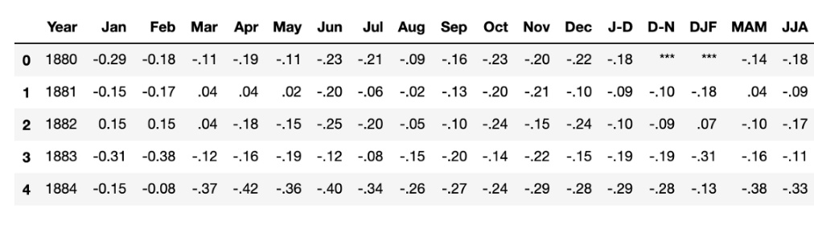

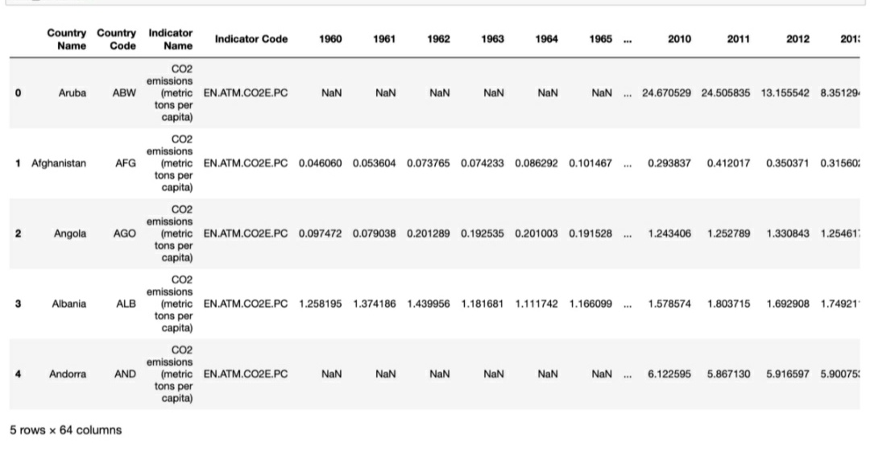

Dealing with anomalies:

The temperature dataset indicates the anomalies of the temperature which is the different between the mean/the expected value per month and the season. We have worked with anomaly values since it has the greater importance than the absolute temperature.

Anomaly values:

Positive-warmer temperature

Negative-cooler temperature

Data wrangling:

Data wrangling is the process of transformation of a raw data into any other format for further analytic purposes.

WRANGLING TEMPERATURE DATA:

By wrangling NASA’s temperature anomaly data we will look at several things:

* Using a DateTime index
* Basically manipulating and dealing with missing values
* Resampling to a different frequency

DATE TIME INDEX:

It’s a package of a pandas which is used for manipulation of the data. For the temperature data we have created a empty data frame using this data time index of monthly frequency for populating the empty data frame we had used the raw data. This empty data frame would range from 1880 to Mar 2019.

BASICALLY MANIPULATING AND DEALING WITH MISSING VALUES:

We have populated the new empty data frame with the anomaly values for every month and these values which we got has some missing value as well as some unusable values. Using a forward fill an pandas package we have cleaned the that missing values.

RESAMPLING TO A DIFFERENT FREQUENCY:

When we have done manipulating and filling those missing values we actually visualized that data but its seem a little bit messy. So for the betterment we have done resampling an packages in pandas were we changed the frequency from month to year.

Similarly we have this wrangling process for the CO2 emission. By this way we have done wrangled. We have found that these two data set trending upwards but with these we cannot prove that the causation the thing is that we if two things are correlated does not mean it’s the cause.

**Conclusion:**

Forecasting using prophet:

For forecasting the climate we have used Facebook prophet library. This library allows for every people even who have a little knowledge or have no experience to predict time series whilst by providing intuitive parameter which are used for a simple tuning.

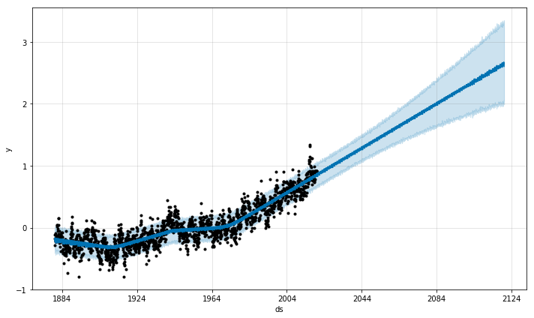

There we have a prediction for global temperature anomalies over the next 100 years! However using this facebook prophet we were able to predict and forecast the climate change. It is essential to save our earth, so that we can make the world, a safer place to live.

**References:**

United nation environment programme ,2005, Atlas of our changing environment.

Jeremy Leggett,1999, The Carbon War :Global warming and the End of the Oil Era

Bill McKibben,2010,Eaarth: Making a Life on a Tough New Planet

Robert H. Shumway ,David S.Stoffer ,2000,Time Series Analysis and its Applications with R example ,third edition